CS 204 OPERATING SYSTEMS
MODULE 1
Operating System Overview – Operations, Functions, Services, Operations System calls Types, Operating system structure- Simple structure, Layered Approach, Microkernel, Modules, System Boot Process

What is an Operating System?
- A program that acts as an intermediary between a user of a computer and the computer hardware
- A program which controls the execution of all other programs (applications).
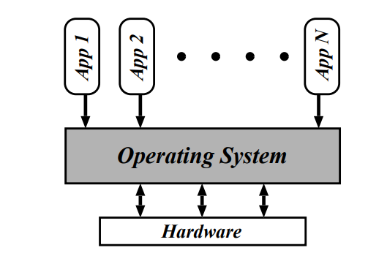
Operating system goals:
- Execute user programs and make solving user problems easier
- Make the computer system convenient to use
- Use the computer hardware in an efficient manner
OS is a resource allocator
- Manages all resources
- Decides between conflicting requests for efficient and fair resource use
OS is a control program
- Controls execution of programs to prevent errors and improper use of the computer

1.Operating System Functions
- Process Management
- Memory Management
- Mass Storage Management
- File System Management
- Device Management
- Protection and Security
- Other important functions

Process Management

- A process is a program in execution.
- In multiprogramming environment, the OS decides which process gets the processor when and for how much time. This function is called process scheduling.
An Operating System does the following activities for processor management −
    - OS allocates the processor (CPU) to a process and also de-allocates processor when a process is no longer required.
    - OS keeps tracks of processor and status of process.
    - Suspending and resuming processes
    - Providing mechanisms for process synchronization, process communication and deadlock handling

Memory Management

- The main memory is central to the operation of a modern computer system.
- To execute a program:
- all (or part) of the instructions must be in memory
- all (or part) of the data that is needed by the program must be in memory.
- Memory management activities
- Keeping track of which parts of memory are currently being used and by whom
- Deciding which processes (or parts thereof) and data to move into and out of memory
- Allocating and deallocating memory space as needed

Mass-Storage Management

- Problems with main memory:
- Main memory is too small to accommodate all data and programs
- When power is lost, the data that it hold are lost
- So secondary storage devices are used to back up the main memory
- disk
- OS activities
  - Free-space management
  - Storage allocation
  - Disk scheduling

File System Management

- A file is a collection of related information.
- A file can be a text file, image, audio, video or may contain data in any other form.
- A file system is normally organized into directories for easy navigation and usage.

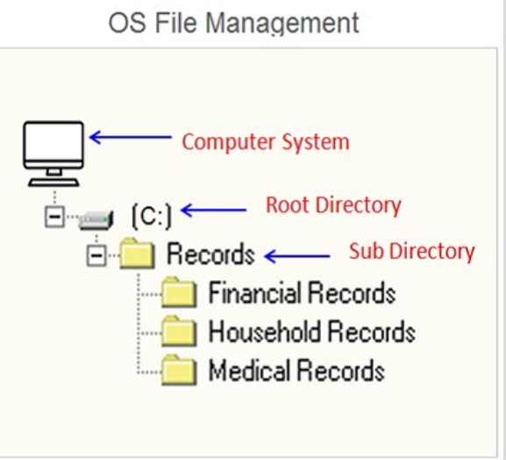

- An Operating System does the following activities for file management
    - Keeps track of information, location, status etc of files
    - Creating and deleting files and directories
    - Primitives to manipulate files and directories
    - Mapping files onto secondary storage

Device Management
- Device management means controlling the input/output devices like disk, microphone, keyboard, printer, magnetic tape, USB ports,camcorder,scanner etc
- It does the following activities for device management −
- Keeps tracks of all devices
- Decides which process gets the device when and for how much time.
- Allocates the device in the efficient way.
- De-allocates devices

Protection and Security

- If a computer system has multiple users and allows the concurrent execution of multiple processes, then access to data must be regulated.
- Only authorized users/processes must access data.
- Protection – any mechanism for controlling access of processes or users to the resources defined by the OS
- Security – defense of the system against internal and external attacks
- including denial-of-service, worms, viruses, identity theft
- By means of password and similar other techniques, it prevents unauthorized access to programs and data.
Systems generally first distinguish among users, to determine who can do what
  - User identities (user IDs, security IDs) include name and associated number, one per user
  - User ID then associated with all files, processes to determine access control
  - Group identifier (group ID) allows set of users to be defined and controls manage, then also associated with each process, file

Other Important Functions

Following are some other important functions of OS:
Control over system performance
  - Recording delays between request for a service and response from the system.
Job accounting
  - Keeping track of time and resources used by various jobs and users.
Coordination between other software's and users
  - Coordination and assignment of compilers, interpreters, assemblers and other software to the various users of the computer systems.

2. Operating System Services

OS Services
- for the user
- for the system

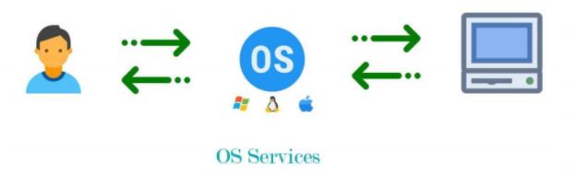
One set of operating-system services provides functions that are helpful to the user:
- User interface - Almost all operating systems have a user interface (UI).

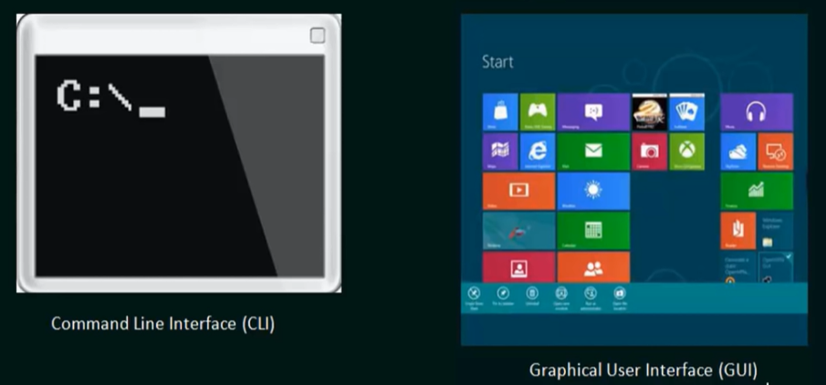
  - Program execution - The system must be able to load a program into memory and run that program, end execution, either normally or abnormally (indicating error)
  - I/O operations - A running program may require I/O, which may involve a file or an I/O device
  - File-system manipulation - Programs need to read and write files and directories, create and delete them, search them, list file Information, permission management.
  - Communications – Processes may exchange information, on the same computer or between computers over a network
    - Communications may be via shared memory or through message passing (packets moved by the OS)
  - Error detection – OS needs to be constantly aware of possible errors
    - May occur in the CPU and memory hardware, in I/O devices, in user program
    - For each type of error, OS should take the appropriate action to ensure correct and consistent computing
    - Debugging facilities can greatly enhance the user’s and programmer’s abilities to efficiently use the system
Another set of OS functions exists for ensuring the efficient operation of the system
  - Resource allocation - When multiple users or multiple jobs running concurrently, resources must be allocated to each of them
    - Many types of resources - CPU cycles, main memory, file storage, I/O devices.
  - Accounting - To keep track of which users use how much and what kinds of computer resources
  - Protection and security - The owners of information stored in a multiuser or networked computer system may want to control use of that information, concurrent processes should not interfere with each other
    - Protection involves ensuring that all access to system resources is controlled
    - Security of the system from outsiders requires user authentication, extends to defending external I/O devices from invalid access attempts
A View of Operating System Services
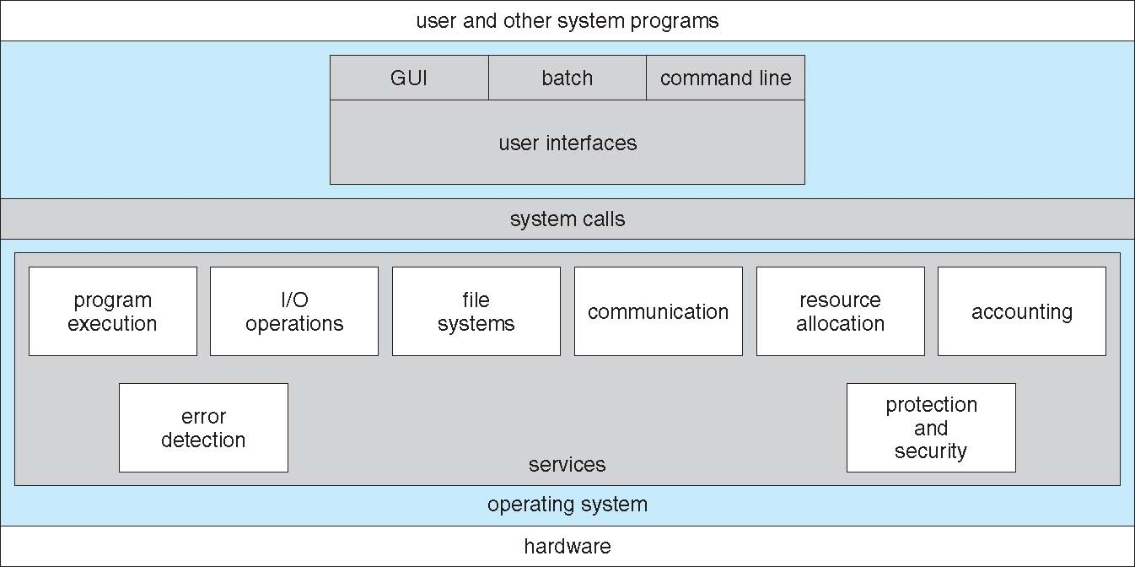

3.Types of Operating Systems
- Batch OS
- Multiprogramming OS
- Multitasking/Time Sharing OS
- Multiprocessing OS
- Distributed OS
- Real Time OS
- Network OS
- Mobile OS
Batch operating systems
The batch operating system does not have a direct link with the computer. A different system divides and allocates similar tasks into batches for easy processing and faster response. The batch operating system is appropriate for lengthy and time-consuming tasks.
Multiprogramming operating systems
It is the ability of an operating system which executes more than one program on a single processor machine. More than one task or program can store or reside into the main memory at one point of time.
Multitasking operating systems
The multiasking operating system, also known as a time-sharing OS, works by allocating time to a particular task and switching between tasks frequently. Unlike the batch system, the time-sharing system allows users to complete their work in the system simultaneously. It allows many users to be distributed across various terminals to minimize response time.

Multiprocessor Operating system
Multiprocessor system means, there are more than one processor which work parallel to perform the required operations.It allows the multiple processors, and they are connected with physical memory, computer buses, clocks, and peripheral devices.The main objective of using a multiprocessor operating system is to increase the execution speed of the system and consume high computing power.
Distributed operating system
This system is based on autonomous but interconnected computers communicating with each other via communication lines or a shared network. Each autonomous system has its own processor that may differ in size and function. A distributed operating system serves multiple applications and multiple users in real-time. The data processing function is then distributed across the processors.
Real-time operating systems
Real-time operating systems provide support to real-time systems that require observance of strict time requirements. The response time between input, processing and response is tiny, which is beneficial for processes that are highly sensitive and need high precision. These processes include operating missile systems, medical systems or air traffic control systems, where delays may lead to loss of life and property.
Network operating systems
Network operating systems are installed on a server providing users with the capability to manage data, user groups and applications. This operating system enables users to access and share files and devices such as printers, security software and other applications, mostly in a local area network.
Mobile operating systems
Mobile operating systems run exclusively on small devices such as smartphones, tablets and wearables. The system combines the features of a personal computer with additional features useful for a handheld device. Mobile operating systems start when a device is powered on to provide access to installed applications. Mobile operating systems also manage wireless network connectivity.
Comparison between Multiprogramming, Multiprocessing and Timesharing operating system
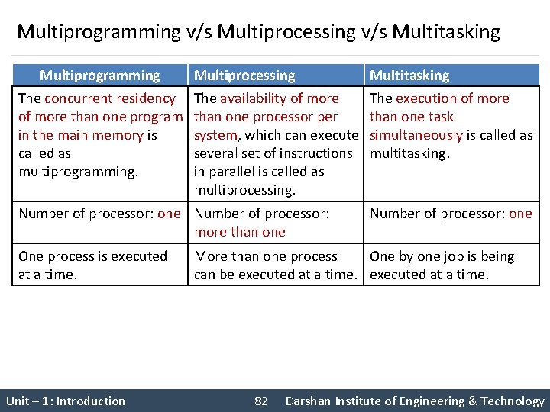
Comparison between Multiprogramming and multitasking OS
Multiprogramming
- Multiprogramming is used for multi-user systems. It means the systems that are used by many users at the same time.
- Multiprogramming means more than one process in main memory which are ready to execute
- It is based on the concept of context switching.
- It takes more time to execute the process.
- The idea is to reduce the CPU idle time for as long as possible.
Multitasking
- Multitasking is used for single-user systems. It means the systems that are used by only one user at the same time.
- Multitasking is when more than one task is executed at a single time utilizing multiple CPUs.
- It is based on the concept of time sharing.
- It takes less time to execute the task or process.
- The idea is allow multiple processes to run simultaneously via time sharing.

4. Operating-System Operations
- There are two modes of operation (dual mode of operation) in the operating system to make sure it works correctly.
- User Mode
- Kernel Mode (supervisor mode, privileged mode, system mode)

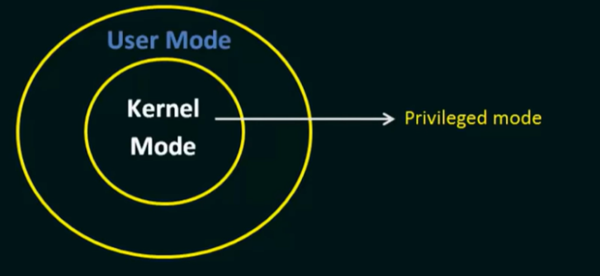

- If a program is executed in
- user mode - then it doesn’t have direct access to the resources (memory, hardware etc)
- Kernel mode – have direct access to the resources
- Mode bit is added to the hardware of the computer to indicate the current mode.

- 1 - User Mode
- 0 - Kernel Mode

Transition from User to Kernel Mode

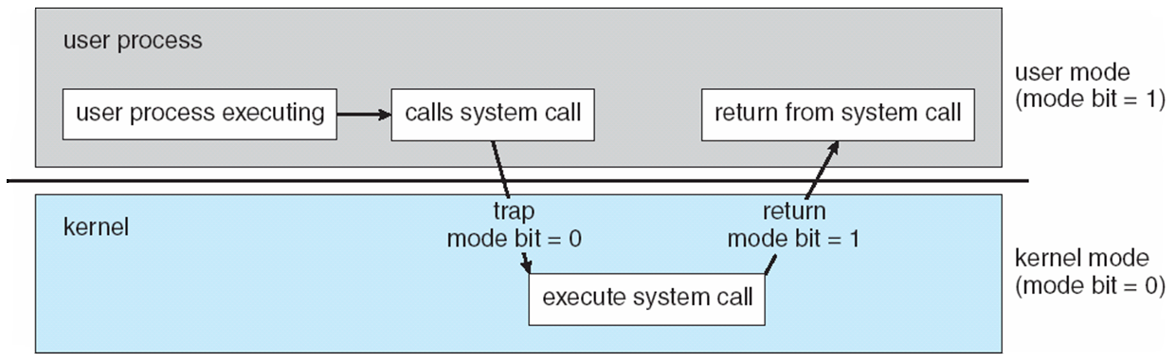

- A trap is a software generated interrupt caused either by a error(eg division by zero or invalid memory access) or by a specific request from a user program to perform an OS service.
Timer to prevent infinite loop / process hogging resources
  - Timer is set to interrupt the computer after some time period
  - Keep a counter that is decremented by the physical clock.
  - Operating system set the counter (privileged instruction)
  - When counter zero generate an interrupt

5. System Calls

- A system call provides an interface between a process and operating system to allow user-level processes to request services of the operating system
- System calls are usually made when a process in user mode requires access to a resource.
- System calls are the only entry points for the kernel system.
- Abbreviated as syscal

Types of System Calls
- Process control
- File management
- Device Management
- Information Maintenance
- Communication
- Protection
Process control
  - create process, terminate process
  - end, abort
  - load, execute
  - get process attributes, set process attributes
  - wait for time
  - wait event, signal event
  - allocate and free memory
  - Debugger for determining bugs, single step execution
  - Locks for managing access to shared data between processes

File management
  - create file, delete file
  - open, close file
  - read, write, reposition
  - get and set file attributes

Device management

  - request device, release device
  - read, write, reposition
  - get device attributes, set device attributes
  - logically attach or detach devices
Information maintenance
- get time or date, set time or date
- get system data, set system data
- get and set process, file, or device attributes
Communications
  - create, delete communication connection
  - send, receive messages from client to server
  - Shared-memory model create and gain access to memory regions
  - transfer status information
  - attach and detach remote devices
Protection
  - Control access to resources
  - Get and set permissions
  - Allow and deny user access

Examples of Windows and UNIX System Calls

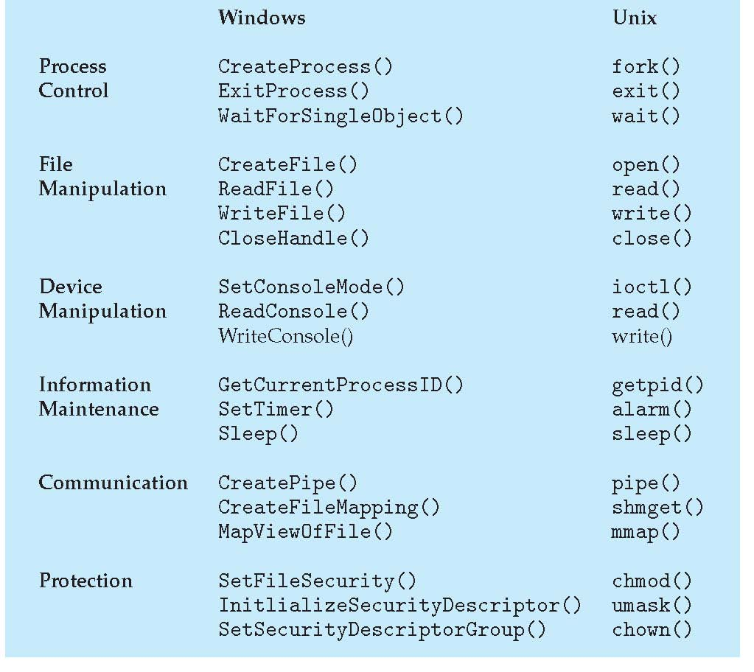
Standard C Library Example
- C program invoking printf() library call, which calls write() system call

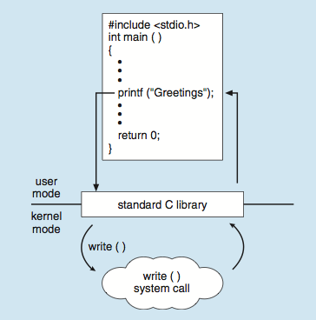

System Call Implementation

- Typically, a number is associated with each system call
- System-call interface maintains a table indexed according to these numbers
- The system call interface invokes the intended system call in OS kernel and returns status of the system call and any return values
System call provides the services of the operating system to the user programs via Application Program Interface(API).
  - API is a set of protocols, routines, and, functions that allow the exchange of data among various applications and devices
    - The caller need know nothing about how the system call is implemented
  - Just needs to obey API and understand what OS will do as a result call
  - Most details of OS interface hidden from programmer by API
    - Managed by run-time support library (set of functions built into libraries included with compiler)

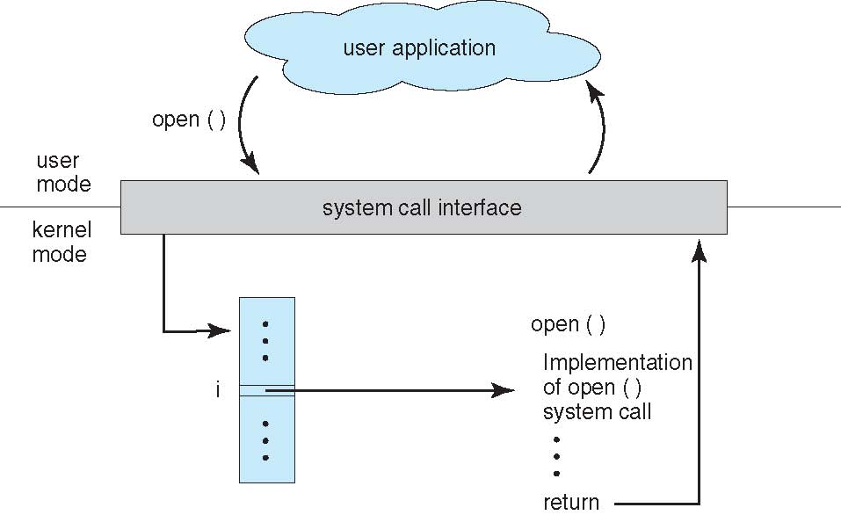

System Call Parameter Passing

- read() system call
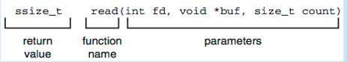
- Three general methods used to pass parameters to the OS
  - Simplest: pass the parameters in registers
    - In some cases, may be more parameters than registers
  - Parameters stored in a block, or table, in memory, and address of block passed as a parameter in a register
    - This approach taken by Linux
  - Parameters placed, or pushed, onto the stack by the program and popped off the stack by the operating system
    - Block and stack methods do not limit the number or length of parameters being passed

Parameter Passing via Table

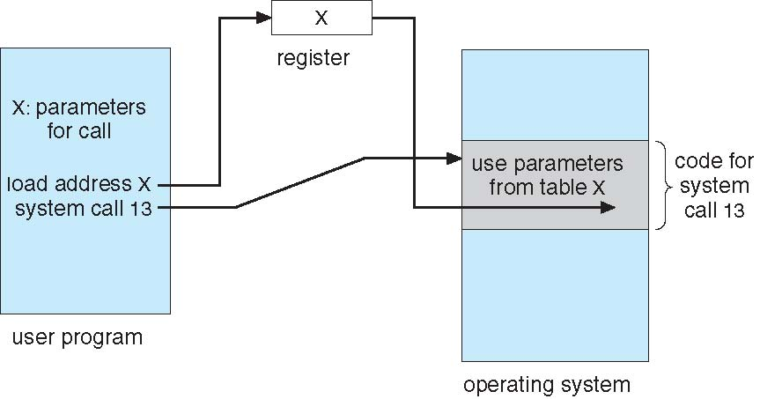

6. Operating System Structure

- Since the operating system is a complex structure, it should be created with utmost care so it can be used and modified easily.
- Different OS structures are:
  - Simple structure
  - Monolithic structure
  - Layered structure
  - Microkernel
  - Modules

a.Simple Structure

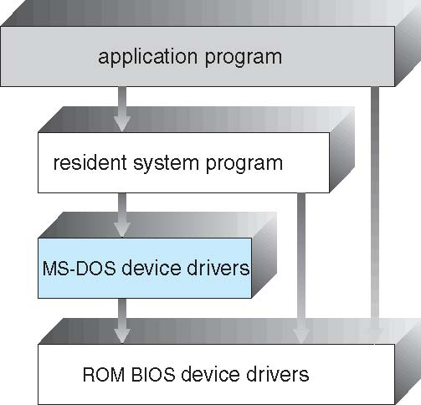

- Application programs are able to access the basic I/O routines to write directly to the display and disk drives.
- Such freedom leaves MS-DOS vulnerable to errant (or malicious) programs, causing entire system crashes when user programs fail.
- MS-DOS was also limited by the hardware of its era.
  - Because the Intel 8088 for which it was written provides no dual mode and no hardware protection, the designers of MS-DOS had no choice but to leave the base hardware accessible
- Not efficient and not a good structure

b.Monolithic Structure
- Earlier UNIX system
- Non simple structure
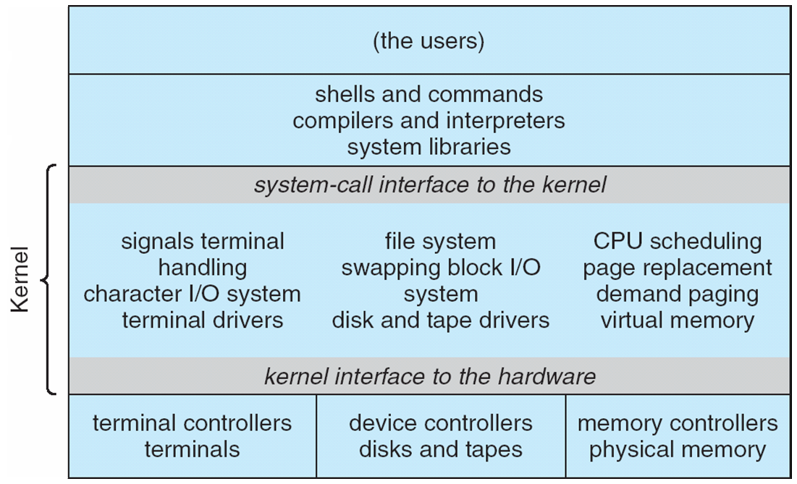
- Consists of two separable parts
  - Systems programs
  - The kernel
    - Consists of everything below the system-call interface and above the physical hardware
    - Provides the file system, CPU scheduling, memory management, and other operating-system functions; a large number of functions for one level ---- Monolithic Structure
    - Every functionality is packed into a single layer.
- Enormous amount of functionality was combined into one level.
- This monolithic structure was difficult to implement and maintain

c.Layered Approach

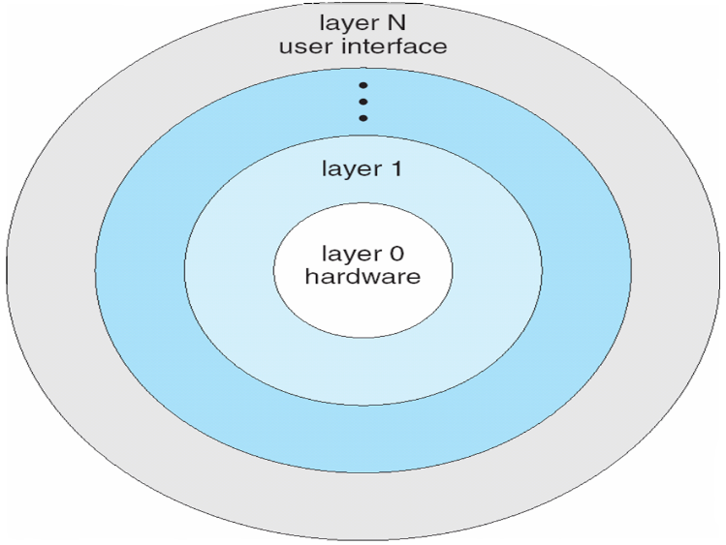
- The operating system is divided into a number of layers (levels), each built on top of lower layers.
- Layers are selected such that each uses functions (operations) and services of only lower-level layers
- A particular layer can access all the layers present below it but it cannot access the layers present above it.
Advantages
  - Simplicity of construction and debugging
Disadvantage
  - Defining various layers appropriately
  - Less efficient
d.Microkernel
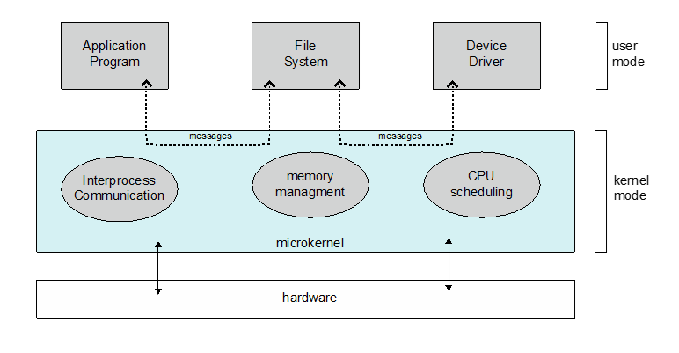
- Removing all nonessential components from the kernel and implementing them as system and user-level programs – Microkernel
- Message Passing
Advantages:
  - Easier to extend OS
    - All new services are added to user space and consequently do not require modification of the kernel
  - Easier to port the operating system to new architectures
    - When the kernel does have to be modified, the changes tend to be fewer, because the microkernel is a smaller kernel
  - More secure and reliable
    - Most services are running as user — rather than kernel — processes.
    - If a service fails, the rest of the operating system remains untouched
Disadvantages:
  - Performance overhead of user space to kernel space communication
e.Modules
- Perhaps the best current methodology for operating-system design is loadable kernel modules
- The idea of the design is for the kernel to provide core services while other services are loaded dynamically when needed, as the kernel is running

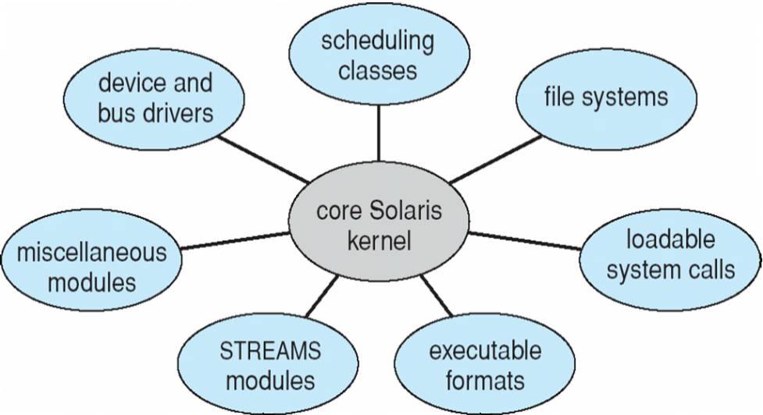
Solaris Modular Approach

- Layered Approach+ Microkernel Approach
- Layered Approach
  - Like layered approach, each kernel section has defined, protected interfaces; but it is more flexible than a layered system, because any module can call any other module
- Microkernel Approach
  - The approach is also similar to the microkernel approach in that the primary module has only core functions and knowledge of how to load and communicate with other modules; but it is more efficient, because modules do not need to invoke message passing in order to communicate
- This type of design is common in modern implementations of UNIX, such as Solaris, Linux, and MacOS X,as well as Windows.
7.System Boot Process
- You press the power button on your laptop/desktop, the CPU gets initialized.
- The CPU looks for the system’s ROM BIOS to obtain the first instruction in the start-up program. This first instruction is stored in the ROM BIOS and it instructs the system to run POST (Power On Self Test).
  - The POST process checks computer hardware, like RAM, hard drive, CD-ROM drive, keyboard, etc., to make sure all are working correctly.
  - If all hardware passes the POST, the computer continues the boot up process and may generate a beep sound as well.
  - If POST is unsuccessful, it generates error encountered and the computer will not boot up. All POST errors are relating to hardware issues with one of the components in the computer.
  - After having configured the basic input and output devices of your PC, BIOS identifies the boot device.
  - After finding the appropriate boot device, the BIOS finds the bootstrap loader (boot record) which tells it to find the beginning of the operating system.
  - The BIOS loads the first 512 bytes from the hard drive of the selected boot device – these 512 bytes are what is commonly known as the MBR, or the Master Boot Record.
  - Once the boot loader loads the operating system, kernel gets loaded.
  - Kernel gets control over the hardware resources of our computer, loads the required drivers, system processes and user space.
  - The users can access the system applications to perform various tasks.

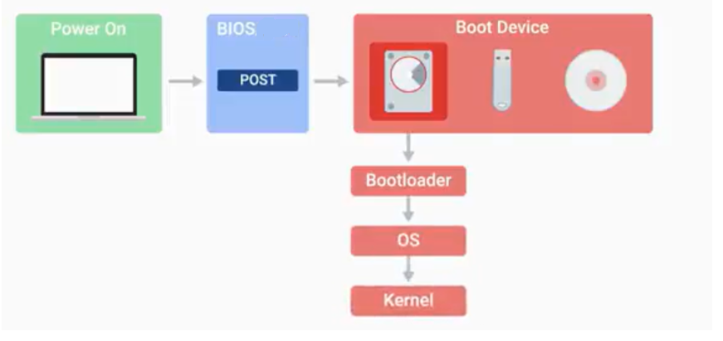
Fork() system call
System call fork() is used to create processes. It takes no arguments and returns a process ID. The purpose of fork() is to create a new process, which becomes the child process of the caller. After a new child process is created, both processes will execute the next instruction following the fork() system call. Therefore, we have to distinguish the parent from the child. This can be done by testing the returned value of fork():
- If fork() returns a negative value, the creation of a child process was unsuccessful.
- fork() returns a zero to the newly created child process.
- fork() returns a positive value, the process ID of the child process, to the parent.
#include <stdio.h>
#include <unistd.h>
int main()
{
int id;
printf("Hello, World!\n");

id = fork();
if (id > 0) {
/*parent process*/
printf("This is parent section [Process id: %d].\n", getpid());
printf(“The value of id is %d”,id);
}
else if (id == 0) {

/*child process*/
printf("fork created [Process id: %d].\n", getpid());
printf("fork parent process id: %d.\n", getppid());
}
else {
/*fork creation failed*/
printf("fork creation failed!!!\n");
}

return 0;
}
Hello, World!
This is parent section [Process id: 1252].
The value of id is 1253
fork created [Process id: 1253].
fork parent process id: 1252.

wait()
wait() forces the parent to suspend execution until the child is finished. wait() returns the process ID of a child process that finished. If the child finishes before the parent gets around to calling wait(), then when wait() is called by the parent, it will return immediately with the child's process ID. The prototype for the wait() system call is:
int wait(status) int *status;
“status” is a pointer to an integer where the UNIX system stores the value returned by the child process.

exec()
The UNIX system calls that transform a executable binary file into a process are the "exec" family of system calls.

exit()
The exit() system call ends a process and returns a value to it parent. The prototype for the exit() system call is:
void exit(status)
int status;
where status is an integer between 0 and 255. This number is returned to the parent via wait() as the exit status of the process. When a process exits with a status of zero that means it didn't encounter any problems. When a process exit with a non-zero status that means it have problems.

stat()
The stat() system call is used to obtain file information.
opendir()
It is used to open directory. The prototype of opendir() is:
DIR *opendir(const char *name);

readdir()
readdir() is used to read a directory

PREVIOUS UNIVERSITRY QUESTIONS
- What is the need for system calls in Operating System?
- How does the hardware find the Operating System kernel after system switch-on?
- What are the advantages of loadable kernel modules?
An operating system would have to include all the systems that provided all anticipated functionalities in the base kernel if there were no loadable modules. This would lead to wastage of memory as most of those systems would not be used often. Also, the users would need to rebuild and reboot the base kernel every time they would require a new functionality.
- Differentiate between the operating System structures?
- How do clustered systems differ from multiprocessor systems?
- What is the main advantage of the microkernel approach to system design?
- How does the distinction between kernel mode and user mode function as a basic form of protection system?
- Write a note on the various services provided by the operating systems.
- Define operating system as resource manager.
- What is the Kernel in operating system?
- What are the advantages of distributed systems?
- What is device management in operating system?
- Explain the function of Shell in brief.
- Define the term Distributed Operating Systems.
- Explain in brief about the functions of kernel and shell.
- Explain different roles of operating system in brief.
- Explain in detail the Layered Architecture of an OS.

